**Students Module**

**1. Create a Student**

**Method: POST**

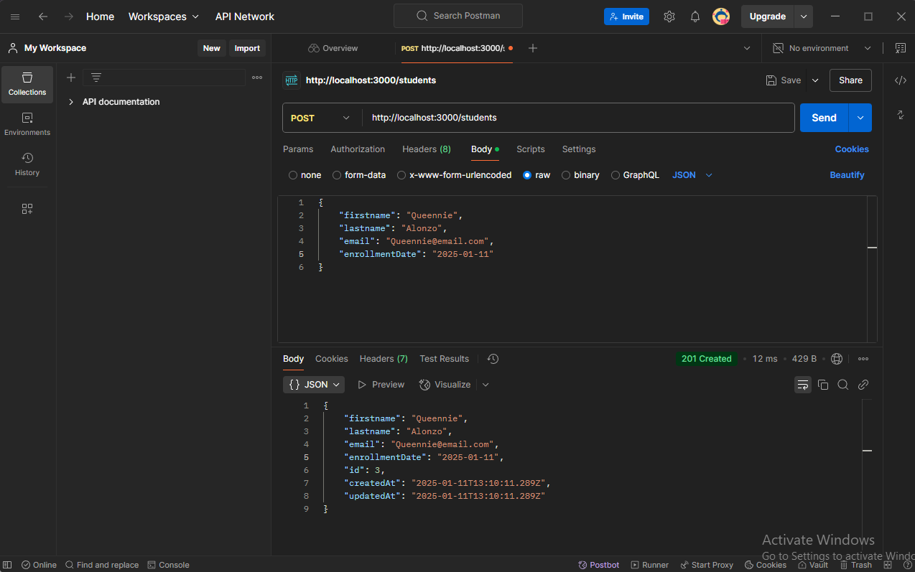

1. **Get All Students**

**• Method: GET**

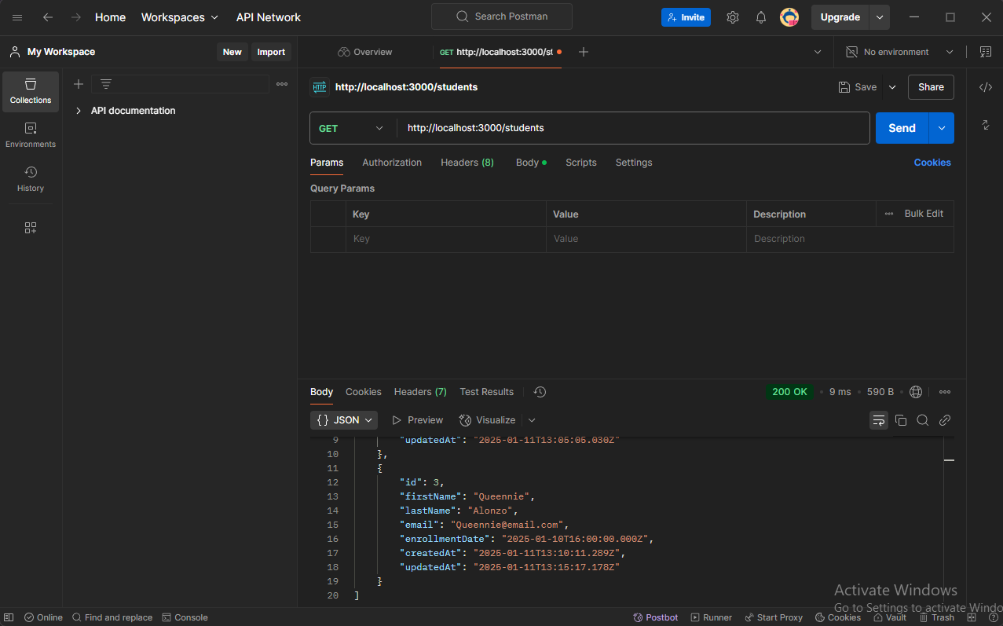

1. **Get a Single Student**

**Method: GET**

